**Cloud based Attendance System for Students/Employees using CNN and LSTM**

**Mr. Sasi Kumar A N Vasanth S**

Assisstant Professor,Department of Computer Department of Computer Science and

Science and Engineering, Panimalar Engineering, Panimalar Engineering

Engineering College, Anna University, College, Anna University,

Chennai, Tamil Nadu, India. Chennai, Tamil Nadu, India.

**Surendar G Vishnu J**

Department of Computer Science and Engineering, Department of Computer Science and

Panimalar Engineering College, Anna Engineering, Panimalar Engineering

University, Chennai, Tamil Nadu, College, Anna University, Chennai,

India. Tamil Nadu, India.

**ABSTRACT:** **In this Virtual Era Institute’s and Corporates are moving towards e-learning and e-training facilities where attendance plays a vital role. Having time constraints as a limit, a lot of time is wasted in taking attendance. In this project we have come with an idea of an automated attendance system and head-count during any live session or at the entrance. There will be no manual work of taking attendance after the implementation of this system. As soon as the users enter the session the attendance will be marked with the time stamp. The head count will be taken in random duration to prevent flaws and attendance will be verified on change of headcount. The Attendance data will be stored in an SQL database and propagated to the website which will be available for the instructor or admin user for cross verification. The Main Objective of this project is to reduce the burden/Work that is carried out manually for taking attendance by replacing it with Smart attendance system using Facial Recognition.**

**Keyword:** **Deep Learning, Cloud computing (Flask).**

**I.INTRODUCTION:**

In this online era the management of the attendance can be a great burden on the teachers, faculty members and organisations as it's done by hand. They also face the problem of proxy attendance, maintaining all hand written document of student attendance of each batch/class every day. Even though smart and auto attendance management system like RF id and biometrics are being utilized, authentication is an important issue in this system. Face recognition is one of the biometric methods to improve this system. Being a prime feature of biometric verification, facial recognition is being used enormously in several such applications, like video monitoring and CCTV footage system, an interaction between computer & humans and access systems present indoors and network security. To resolve this problem, we introduce Facial Recognition based Smart Attendance System for Students/Employees. In this project we build an Web Application powered by Amazon EC2 0.3Linux instance to display marked Attendance from the SQL Database. The output from the conference screen is taken as an input for the system. The input screen is converted to gray scale and feeded  to model trained using haarCascade to extract facial data sets and head count. The extracted facial dataset is passed to an model trained using Convolutional neural network (CNN) having Long short-term memory (LSTM). The model is trained With the help of pre-trained data stored in Key-Value pair in Mongo DB. Once the prediction is done the predicted values are stored in LSTM for future and fast processing. The attendance is updated in MySQL Database for backend services like Flask to fetch and propagate in Admin / staff login portal. This portal allows the instructor to edit and update the attendance entered by the system. Performance of the system is increased with encouraging results of initial experiments. As a part of fool proof when the users enter the session the attendance will be marked with the time stamp. The head count will be taken in random duration to prevent flaws and attendance will be verified on change of headcount.

**II. LITERATURE SURVEY:**

Large datasets can be easily ingested and managed using cloud computing for deep learning, and deep learning models can scale efficiently and at lower costs using GPU processing power. Deep learning on the cloud allows you to design, develop, and train deep learning applications more quickly by leveraging distributed networks.

Hao Yang And Xiaofeng Han [1] Proposed the Concept Of Attendance System Based On Face Recognition Technology Is Proposed, And The Research On Face Recognition Attendance System Based On Real-Time Video Processing Is Carried Out Using Cnn Algorithm With Steps Of Face Recognition, Geometric Feature Method, Subspace Analysis Method ,Neural Network Method And Support Vector Method. The Process Involves Complex Procedure And The Efficiency Is About 82%.

[N Palanivel](https://ieeexplore.ieee.org/author/37085595877);[S Aswinkumar](https://ieeexplore.ieee.org/author/37087058726); [J Balaji](https://ieeexplore.ieee.org/author/37085709548) [2] proposed a attendance system using a K-means clustering algorithmic rule is employed to research the facial expression. The biometric features of the face unit are extracted and also the K-mean clustering technique is used to cluster the face features. Then, SVM methodology is employed to classify the features of the image. Finally, a report is generated for interpretation.

Kaneez Laila Bhatti , Laraib Mughal , Faheem Yar Khuhawar , Sheeraz Ahmed Memon[3] proposed a Smart Attendance Management System which deep learning techniques to develop this system, The frontend side (client side) which consist of GUI which is based on electron JS and backend side consist of logic and python (server side), an IPC (Inter Personal Communication) bridge is developed to communicate these two stacks. The images capture by the camera is sent to system for further analysis, the input image is then compared with a set of reference images of each of the student and mark their attendance.

Sakshi Patel, Prateek Kumar , Shelesh Garg , Ravi Kumar[4] used recognizer library for facial recognition and storing attendance. The absentee’s supervisor or parents are informed through email regarding the absence of their employees or wards respectively. The objective of this project is to innovate existing projects with some added feature like large data storage and fast computing through less hardware cost.

[Anshun Raghuwanshi](https://ieeexplore.ieee.org/author/37086331510); Preeti D Swami [5] proposes and compares the methodologies for an automated attendance system using video-based face recognition. Face recognition is performed and compared on the basis of the accuracy of recognition using Principle Component Analysis (PCA) and Linear Discriminant Analysis (LDA) algorithms.

**III. PROPOSED WORK:**

The goal of this project is to create a Web Application that uses an Amazon EC2 Linux instance to display marked Attendance from a SQL Database. The output from the conference screen is used as the system's input. To extract facial data sets and count heads, the input screen is converted to grey scale and fed to a model trained with haarCascade. The extracted facial dataset is fed into a Convolutional Neural Network (CNN) model with a long short-term memory (LSTM). The model is trained using pre-trained data stored in MongoDB as a Key-Value pair. Once the prediction is complete, the predicted values are stored in the LSTM for future use. The attendance is upgraded in a MySQL database for backend services such as Flask to fetch and propagate in the admin/staff login portal. This portal allows the instructor to edit and update the system's attendance records. The system's performance has improved as a result of promising preliminary results. When users enter the session, their attendance will be recorded with a time stamp as part of Fool proof. To avoid faults, the head count will be done at random intervals, and attendance will be checked when the headcount changes.

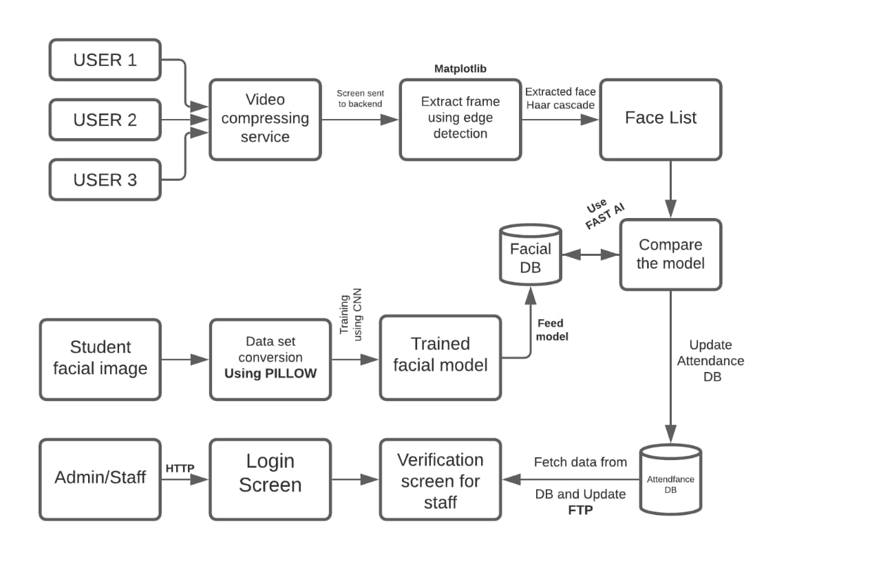

*Fig 1 -Block diagram representing the process flow.*

**IV.SYSTEM IMPLEMENTATION:**

The proposed work is implemented by the use of the two architecture or two modules

1. Base Architecture
2. Admin staff login Architecture.

**Architecture / Methodology used:**

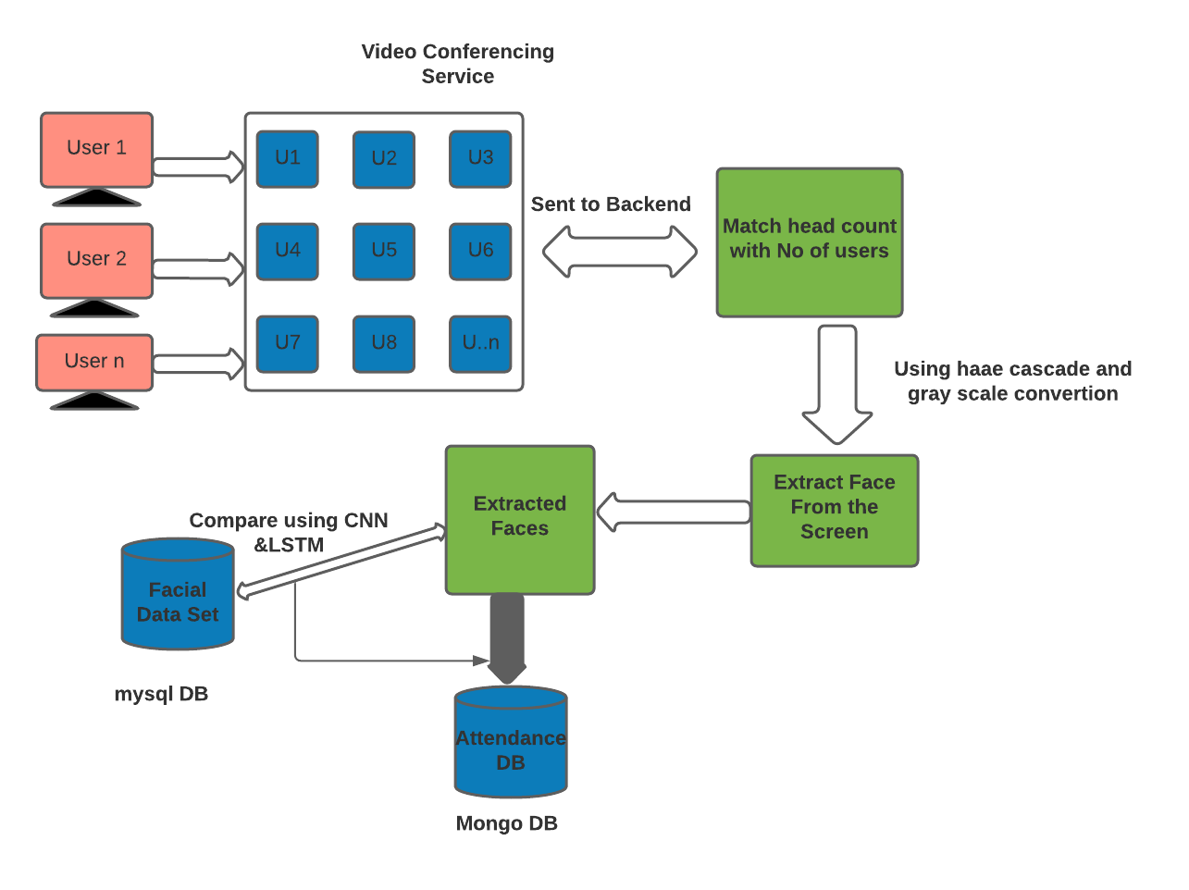

*Fig 2-Base Architecture*

When the user uses the video conferencing service the video is sent to backend which matches the head count with the number of users.Using haae cascade and grey scale conversion face is extracted from the screen and the extracted faces stored in attendance DB (Mango DB) is compared with the facial data set in mySql using CNN and LSTM.

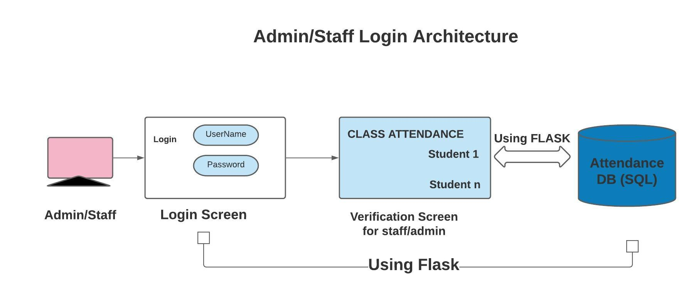

*Fig 3-Admin/staff Login Architecture.*

When the admin logins into the attendance screen verification screen for class attendance is opened which are stored in Attendance DB and it is done by using flask, Python library used for developing web applications.

**V.RESULTS:**

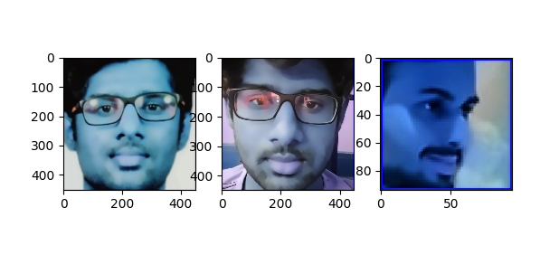

Fig 4- Process 1 Crop

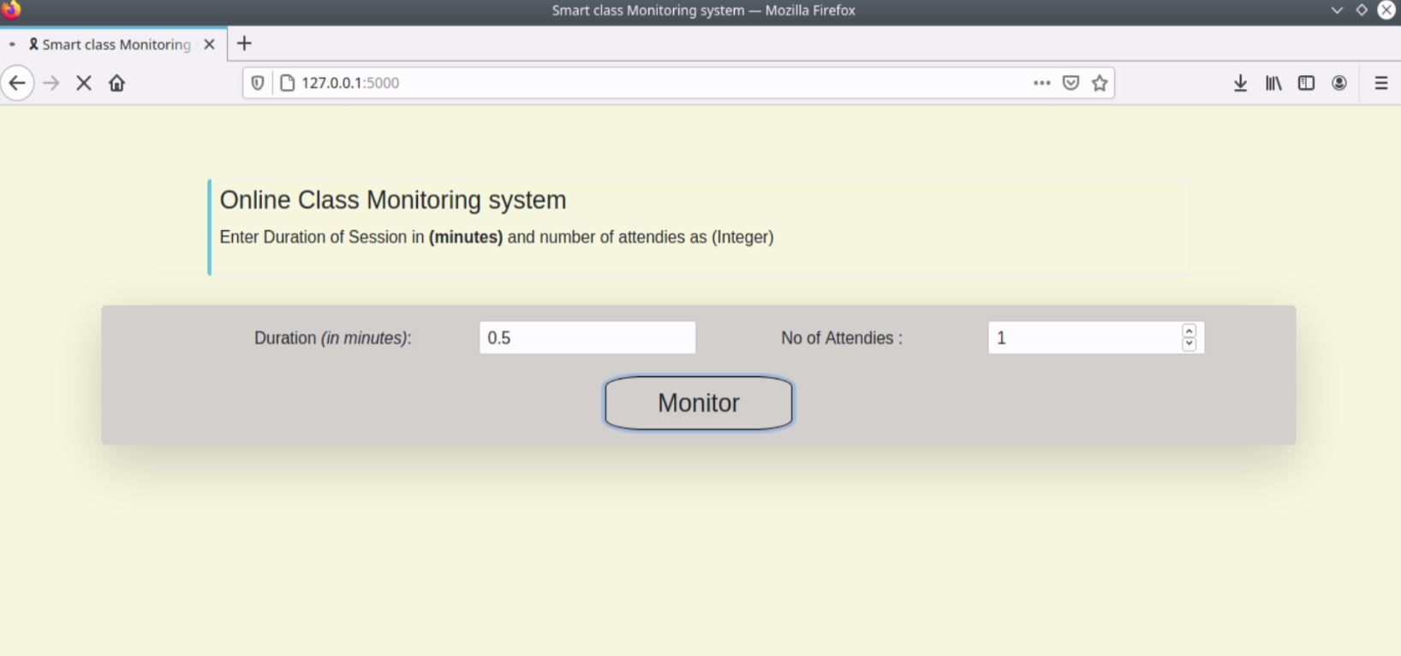

Fig 5-Portal Screen

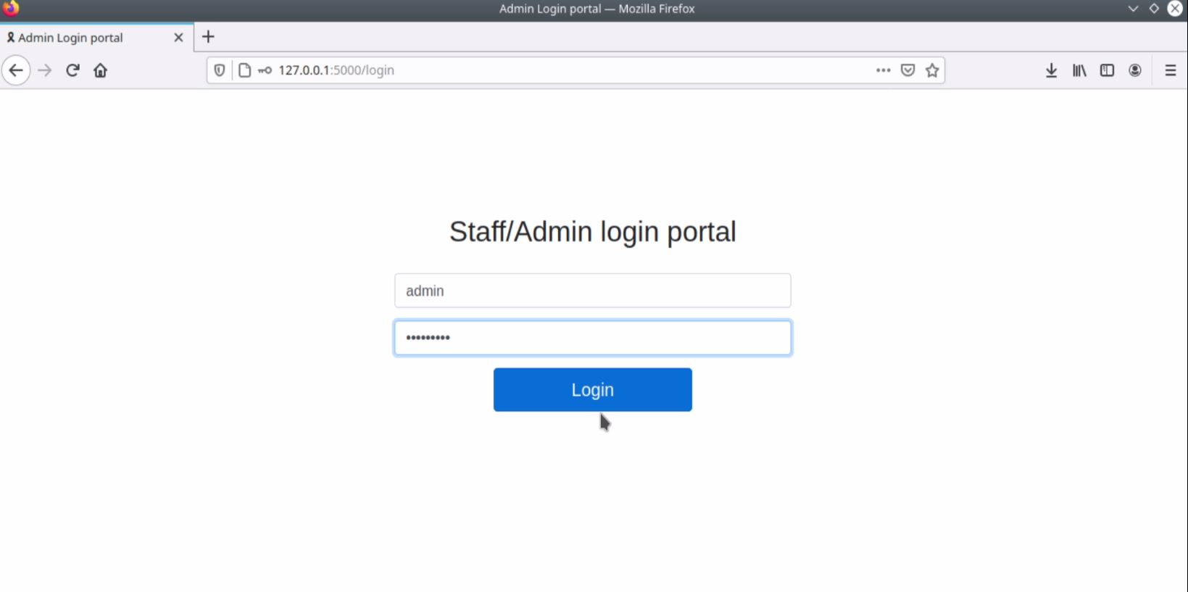

Fig 6-Staff/Admin Login

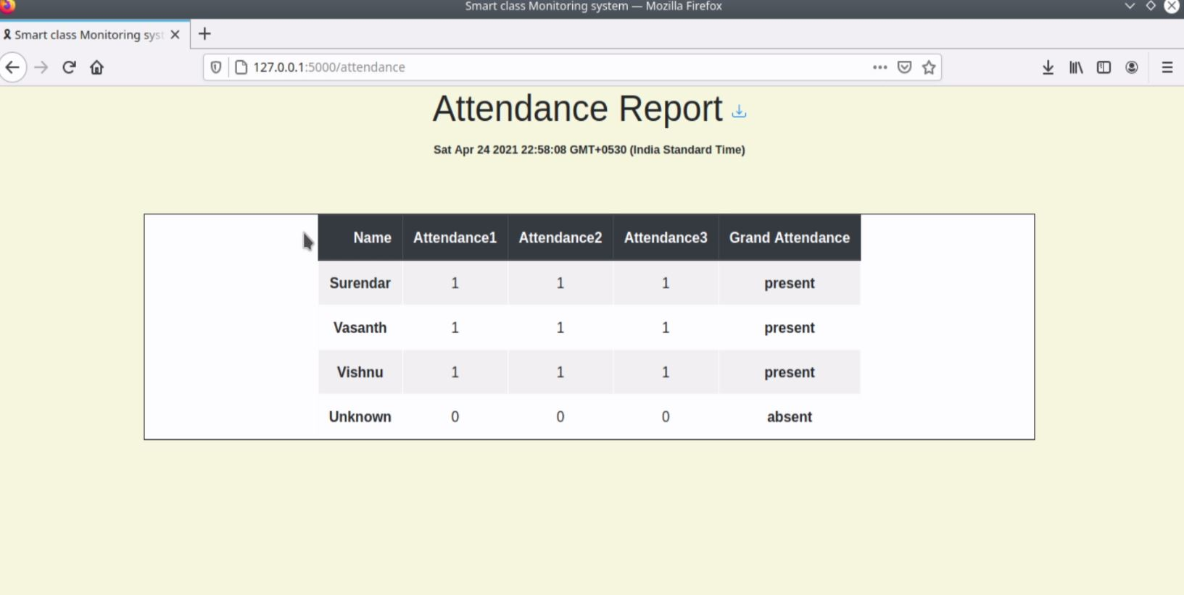

Fig 7-Attendance Screen

**VI. CONCLUSION:**

Cloud based Attendance System for Students/Employees using CNN and LSTM is done successfully. The main objective is to reduce the implement a simple architecture flow hence by reducing the over all complexity in smart attendance system is achieved using deep learning technique and hence by increasing the system performance.

**VII.REFERENCE:**

[1]<https://ieeexplore.ieee.org/document/9138372> Hao Yang And Xiaofeng Han,” Face Recognition Attendance System Based on Real-Time Video Processing”, IEEE ACCESS,2020

[2][N Palanivel](https://ieeexplore.ieee.org/author/37085595877),[S Aswinkumar](https://ieeexplore.ieee.org/author/37087058726); [J Balaji](https://ieeexplore.ieee.org/author/37085709548),” Automated Attendance Systems Using Face Recognition by K-Means Algorithms”,IEEE,2019.

[3]Kaneez Laila Bhatti , Laraib Mughal , Faheem Yar Khuhawar , Sheeraz Ahmed Memon ,” Smart Attendance Management System Using Face Recognition”,EIA,2019

[4]Sakshi Patel, Prateek Kumar , Shelesh Garg , Ravi Kumar ”Recognition based smart attendance system using IOT”,IJCSE,2018

[5][Anshun Raghuwanshi](https://ieeexplore.ieee.org/author/37086331510); Preeti D Swami,“An automated classroom attendance system using video based face recognition”,IEEE,2017

[6] C. Ding and D. Tao, ‘‘Trunk-branch ensemble convolutional neural networks for video-based face recognition,’’ IEEE Trans. Pattern Anal. Mach. Intell., vol. 40, no. 4, pp. 1002–1014, Apr. 2018.

[7] V. B. Nemirovskiy, A. K. Stoyanov, and D. S. Goremykina, ‘‘Face recognition based on the proximity measure clustering,’’ Inst. Cybern. Tomsk Polytech. Univ., vol. 40, no. 5, pp. 740–745, 2016.

[8] K. Taniya, M. Nidhi, and T. Nandini, ‘‘Automated human resource and attendance management system based on real time face recognition,’’ IJSRSET, vol. 16, no. 4, pp. 847–853, 2016.

[9] D. Wu, Y. Tang, G. Lin, and H. Hu, ‘‘Roboust face recognition based on significance local directional pattern and deep learning,’’ J. Optoelectron. Laser, vol. 27, no. 6, pp. 655–661, 2016. [10] Y. Sun, J. Zhao, and Y. Hu, ‘‘Supervised sparsity preserving projections for face recognition,’’ Proc. SPIE, vol. 8009, no. 4, pp. 357–366, 2017.

[11] L. Best-Rowden and A. K. Jain, ‘‘Longitudinal study of automatic face recognition,’’ IEEE Trans. Pattern Anal. Mach. Intell., vol. 40, no. 1, pp. 148–162, Jan. 2018.

[12] T. Valentine, M. B. Lewis, and P. J. Hills, ‘‘Face-space: A unifying concept in face recognition research,’’ Quart. J. Experim. Psychol., vol. 69, no. 10, pp. 1996–2019, Oct. 2016.

[13] Y. Duan, J. Lu, J. Feng, and J. Zhou, ‘‘Context-aware local binary feature learning for face recognition,’’ IEEE Trans. Pattern Anal. Mach. Intell., vol. 40, no. 5, pp. 1139–1153, May 2018.

[14] S. Chakraborty, S. K. Singh, and P. Chakraborty, ‘‘Local gradient hexa pattern: A descriptor for face recognition and retrieval,’’ IEEE Trans. Circuits Syst. Video Technol., vol. 28, no. 1, pp. 171–180, Jan. 2018.